Subject: Protect the Health of You and Your Loved Ones - Sign Up For Benefits

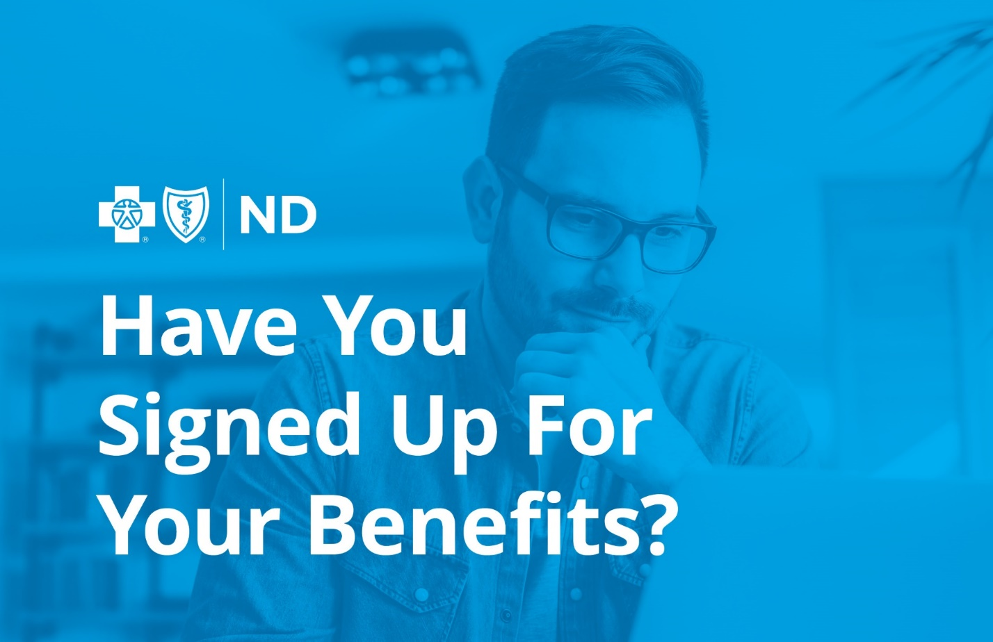

Open Enrollment is here!
It's time to sign up for your benefits, including your employer-sponsored health insurance from Blue Cross Blue Shield of North Dakota (BCBSND).

Review your options, choose your benefits
Protect the health of you and your loved ones by choosing a plan and making the most of your benefits. Unless you have a qualifying event in your life, Open Enrollment is your once-a-year opportunity to sign up for health insurance.

A message from your employer
[In this space, you can promote open enrollment dates, meetings, and other details related to your open enrollment process.]

Have Questions?
Please email [name of internal benefits manager] at [email/phone] if you have any questions.

Blue Cross Blue Shield of North Dakota is an independent licensee of the Blue Cross Blue Shield Association

