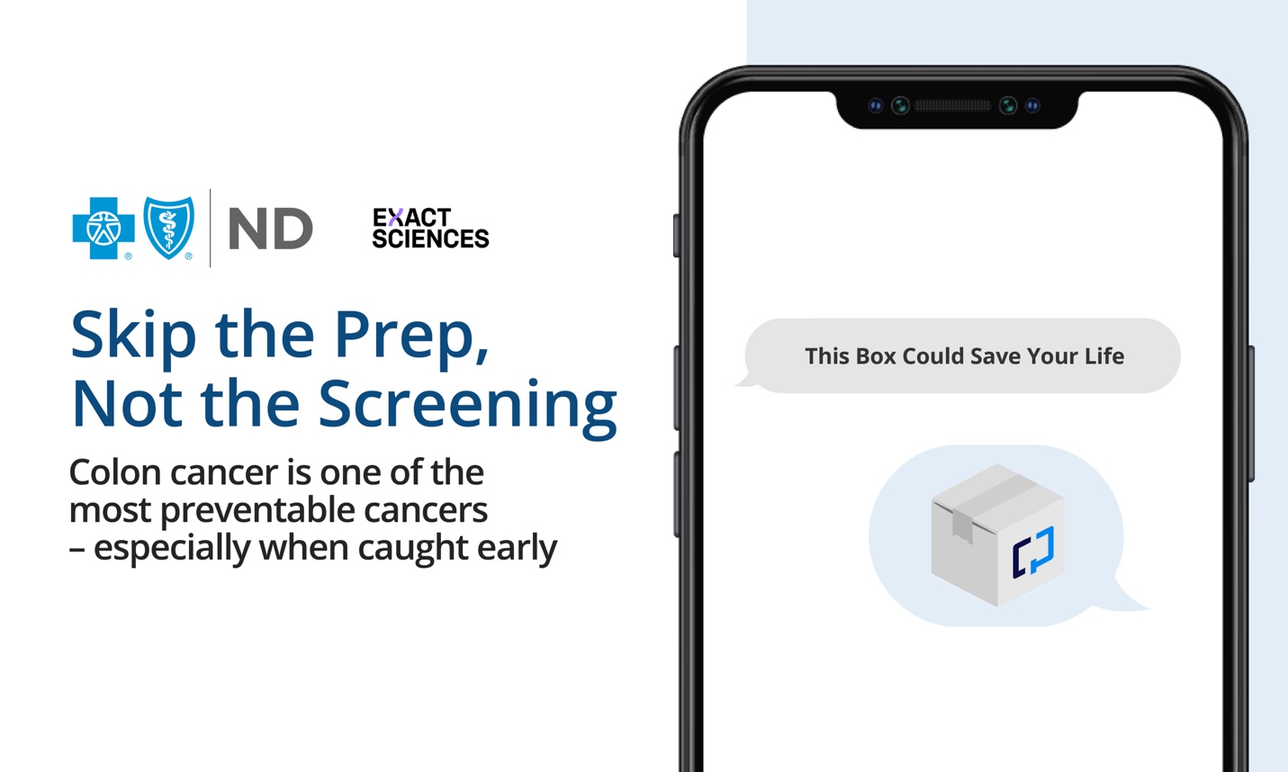
Colon cancer is one of the most preventable cancers, especially when caught early. Eligible employees (adults 45+) can access Cologuard®, a noninvasive at-home test covered by our insurance. No prep, no sedation, and no time off work, just complete the kit at home if you qualify. Early detection saves lives. Learn more at, Cologuard.com/how-to-use-cologuard

