To make the new system migration easy for you to share, we've provided messages below that can be shared via email, intranet or through another communication channel of your choosing.
Yellow highlights indicate content that should customize based on anniversary date.
A note about the digital experience: your employees can continue to access BCBSND.me until their 2027 coverage starts. Once 2027 coverage begins, they will be guided to set up a new digital account, even if the member has the BCBSND.me bookmarked.

Digital Account and app
Streamlined benefits website and app
Blue Cross Blue Shield of North Dakota (BCBSND) will have a revitalized digital experience available making it easier for employees and family members to gain access to tools to help navigate your health plan benefits.
Available via desktop and mobile app starting January 2027, BCBSND.com and the BCBSND Health Insurance mobile app will offer more personalization and guided support, including tools to help you:
- Access your claims, track your deductibles and access EOBs
- View benefit details to know what is covered and access treatment cost tools to plan ahead for your care needs
- Search for high-quality in-network care near you and explore virtual care options
- Receive personalized messages to keep you on track with your preventive health care needs
- Access Doctor on Demand for virtual care and other value-added programs
- Connect with customer service via chat, phone, or email
When you receive your new member ID card, you will want to create a new digital account on BCBSND.com and download the new mobile app.
On <RENEWAL DATE>, you will no longer have access to BCBSND.me but your coverage information will transfer to your new account, including three years of claims history.
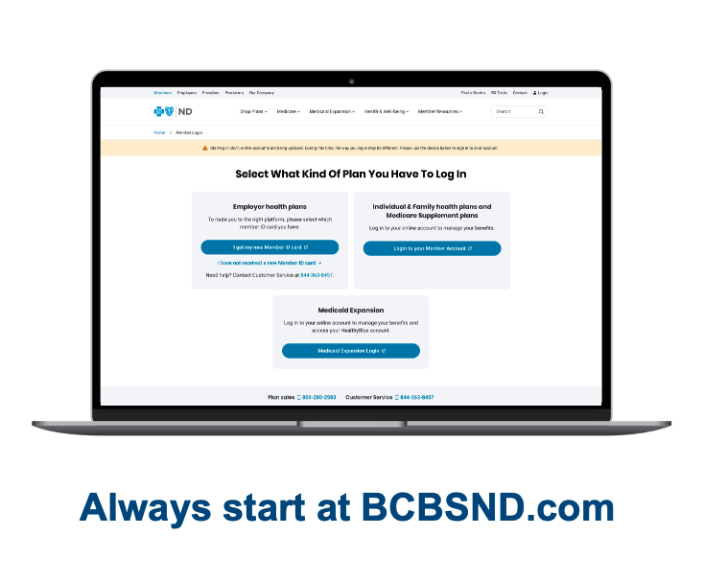

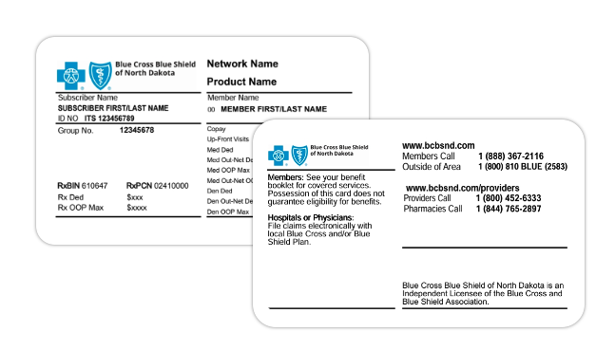
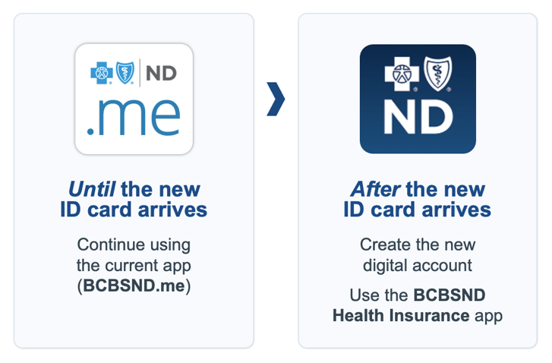
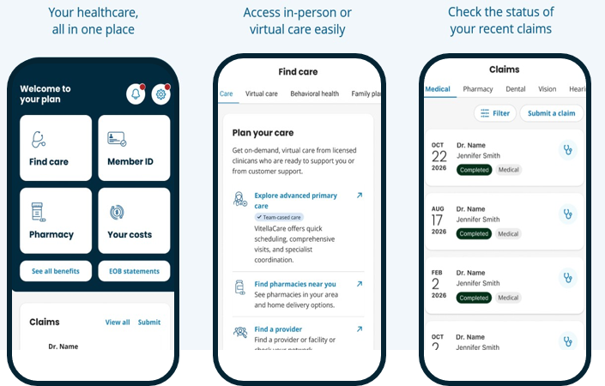

Communications from BCBSND
If BCBSND has an email address and mobile phone number for you, you will receive welcome emails and a digital copy of your new member ID card via SMS.
These communications are safe and trusted from:
- Email: info@notifications.bcbsnd.com
- Claims texts: 326897
- Other texts: 525767

Introducing Empower360
As we continue to enhance your wellness experience, Blue Cross Blue Shield of North Dakota (BCBSND) is launching Empower360, a comprehensive digital wellbeing platform that builds on what you've experienced with expanded features, more ways to earn rewards, and more.
Available via desktop and mobile app starting <RENEWAL DATE>, Empower360 is a digital hub that brings wellness programs, health tracking, and rewards together in a guided experience. Features available to help you maximize your personal health include:
- Health Assessment and wellness score to help you understand your current health status, receive personalized recommendations, and track your progress over time
- 25+ digital programs and over 40 wellness challenges to help you learn and practice new health habits
- Device integration and tracking through the mobile app with 100+ device integrations
- Health library full of wellness tools, videos, podcasts, and articles on popular health topics
- Meaningful rewards for healthy behaviors and preventive care activities
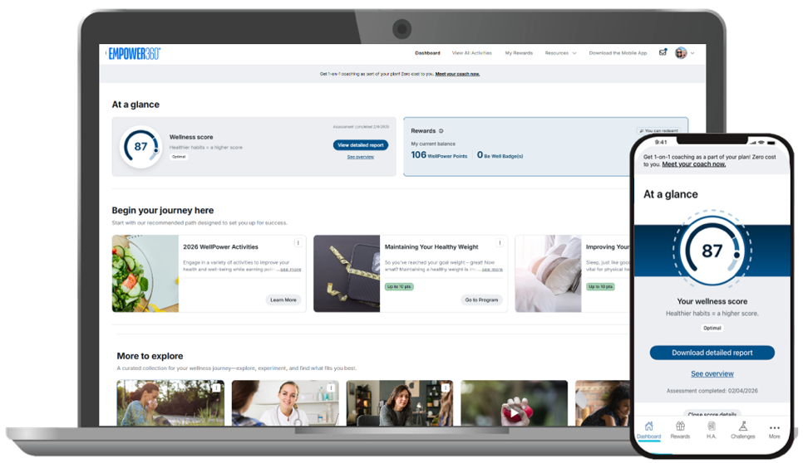
This resource will help you take a more active role in managing your health and your family's wellness.
Introducing Empower360 Rewards
Empower360 introduces an innovative rewards program that recognizes wellness comes from many activities, including proactively engaging in your health care.
The Empower360 Rewards program will reward several healthy activities throughout the year, and you can earn those rewards towards digital gift cards* to redeem. You and your spouse on the plan will be eligible to earn up to $250 in digital gift cards each.
*Please note, any gift card earnings count as taxable income, which will be reflected on your paystub.

Additional Empower360 Assets

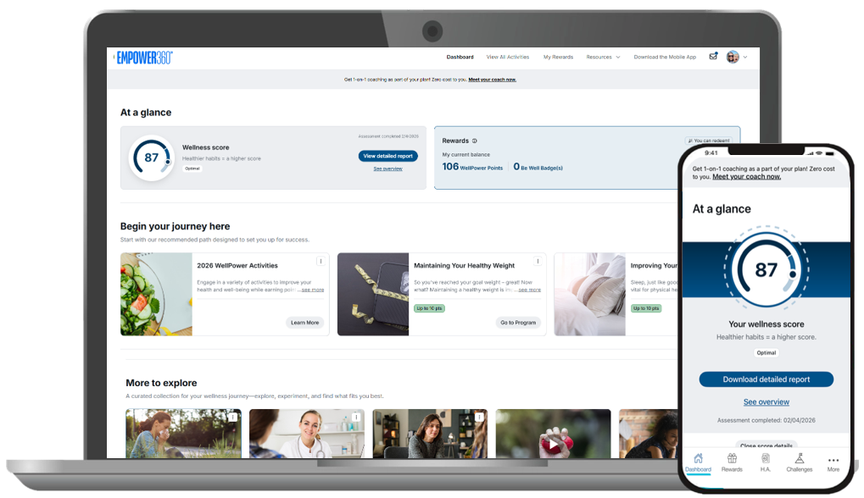

Make the most of your health coverage for 2027
Make the most of your BCBSND health plan
Blue Cross Blue Shield of North Dakota (BCBSND) gives you trusted coverage, local support and convenient ways to manage your care. As your new plan experience begins, here are a few simple steps to help you get started and stay connected.
Use your new member ID card
Bring your new member ID card when you visit the doctor, pharmacy or other care provider. Your card has important information your provider needs to confirm your coverage and process claims correctly. If you have questions, call the customer service number on your new member ID card.
Create your new online account
Set up your account at BCBSND.com to view your benefits, track claims, access wellness rewards and find helpful plan information. When the new plan starts, you’ll use the new website instead of bcbsnd.me. Three years of your information will move over.
Get care and support when you need it
You’ll have convenient options for care and support, including 24/7 online care through Doctor on Demand and nurse advice anytime, day or night, through Advice24.
Manage your plan on the go
Download the BCBSND Health Insurance app when it’s available to access your member ID card and benefits wherever you are.
Explore wellness rewards
Earn rewards for healthy activities through your new wellness program. Sign in at BCBSND.com to learn more and see what’s available to you.
Tip: Keep your new member ID card handy and create your online account soon after your plan starts so you’re ready when you need care.

Access programs through BCBSND.com
When you get your new member ID card, be sure to register your account on BCBSND.com to access your wellness program and other great benefits shown below.
VitellaCare, managed by Crossover
Short Description: Get primary care, mental health, lab work and more from your trusted care team at VitellaCare. Book an appointment and learn more at vitellacare.com.
Long Description: Health care feels more personalized and accessible at VitellaCare. Get primary care, mental health, preventive care, lab draws and more – all in one place from a trusted care team. Book an appointment and learn more at vitellacare.com.
Amazon Pharmacy with MedsYourWay®
Short Description: Order your medicine online for less, with free shipping and help from pharmacists. Sign up at amazon.com/bcbsndmeds.
Long Description: Save money by ordering your medicine online. Get discounts and free shipping with this online pharmacy. Plus, pharmacists are available 24/7. To get started, sign up at amazon.com/bcbsndmeds.
Omada
Short Description: Reduce your risk for diabetes and heart disease with Omada. You can find this virtual program on BCBSND.me.
Long Description: Reduce your risk for diabetes and heart disease with Omada. This virtual program offers coaching, tools and support to help lose weight and build healthy habits.
Sword Health
Short Description: Prevent and recover from joint, muscle or movement pain on your time, in your space with Sword Health. Find it in BCBSND.me.
Long Description: Prevent and recover from joint, muscle or movement pain on your time, in your space with Sword Health. It’s a virtual program that pairs you with a doctor of physical therapy and tech to help you move better, feel stronger and live pain free. Find it in BCBSND.me.
meQ, or meQuilibrium
Short Description: Build resilience and lower stress with tools and support from meQ. You can find this virtual program on BCBSND.me.
Long Description: Build resilience and lower stress with meQ. This virtual program offers simple tools and personal support to help with stress, burnout, anxiety and focus. Find it in BCBSND.me.
Doctor on Demand
Short Description: Doctor On Demand expands access to both medical and behavioral health care through a single virtual platform available nationwide.
Long Description: Doctor On Demand expands access to both medical and behavioral health care through a single virtual platform available nationwide. Members can connect with providers 24/7 for urgent care needs, often in less than 10 minutes, while also gaining rapid access to therapy and psychiatry appointments.
Advice24
Short Description: Advice24 gives members immediate access to registered nurses 24 hours a day, seven days a week.
Long Description: Advice24 gives members immediate access to registered nurses 24 hours a day, seven days a week. Whether they're deciding if symptoms require emergency care, a provider visit or self-care, they can receive trusted guidance by phone or chat. By helping members make informed care decisions and directing them to appropriate, cost-effective care options, Advice24 supports both a better member experience and better healthcare utilization.
Care Management Program
Short Description: If you have a difficult medical situation, our experienced care managers are here to give you the one-on-one support you need.
Long Description: If you have a difficult medical situation, our experienced care managers are here to give you the one-on-one support you need. They’ll help you navigate the healthcare system and answer all your questions while taking your specific condition into consideration.
Pregnancy Program
Short Description: Get support from nurses through your pregnancy.
Long Description: Get added support before, during and after pregnancy. Nurses offer personalized guidance, resources and care to help you have a healthy pregnancy and adjust to life with your baby.

