BCBSND.me will make it easier for your employees to manage their benefits and navigate care starting in January 2025. To make it easy for you to encourage your employees to use this new app and online portal, we've provided messages and recommended timelines to promote this new tool across multiple channels.
If you have questions, we're here to help. Just let us know what you need.

PRELAUNCH & LAUNCH COMMUNICATIONS PLAN
This toolkit is designed to create awareness of this new tool with your employees.
Once BCBSND.me launches in January, we recommend focusing on guiding your employees to set up an account and download the app. Sharing personal stories from leaders or wellness ambassadors may also spark interest with your employees.
Timeline | Recommend Channels | Distribution | Messaging
Dec. 1 – 15 | Email, Intranet | From HR or Leadership | Meet BCBSND.me, your personalized health navigator  Blue Cross Blue Shield of North Dakota (BCBSND) is launching a new digital tool – BCBSND.me – making it easier for those on our BCBSND health plans to manage benefits and navigate care.  This will replace your current BCBSND online account and the HealthyBlue wellness app.  Available via desktop and mobile app starting January 2025, BCBSND.me is a great resource to help you view medical claims, search for providers and specialists, and access an extensive library of wellness tools, programs and services.  BCBSND.me can also connect you with high-touch care guides to help you:  - Identify and understand you, including wellness programs  - Schedule medical appointments on your behalf  - Send you timely notifications to help you manage your health  In January, you will receive communication from BCBSND on registering for your BCBSND.me account via text and email. In the meantime, you can learn more about the digital experience here.  Sincerely,  <LEADER>
Jan. 1 – 10 | Signage (physical and digital) | Environmental Signage | We recommend downloading these resources from our library of signage options and placing in high-traffic spaces such as digital displays, breakrooms or other common areas.  11x17 Poster  8.5x11 Flyer  1920x1080 Digital Display  Video
Jan. 9 – 15 | Email, Intranet | From HR or Leadership | BCBSND.me, your personalized health navigator is now live  We are excited to share that you can now download the BCBSND.me app or visit BCBSND.me and create an account!  BCBSND.me offers a digital hub that brings health management programs and services together in a data-driven, personalized and guided experience.  Through BCBSND.me, members can:  - View out-of-pocket costs, deductibles and more in one place  - Access wellness tools, set health goals and earn rewards  - Confidently search for providers with personalized, in-network results  - Get personal support anytime through chat or phone  BCBSND.me replaces your current BCBSND online account and HealthyBlue wellness app. You can access BCBSND.me via the web or download the mobile app.
Feb. 3 – 7 | Email, Verbally | From HR or Leadership | Have you tried out BCBSND.me yet?  BCBSND.me has been available for a little over a month. Have you tried it yet?  This innovative tool is designed to simplify your health care experience and empower you to take control of your health.  I've personally found BCBSND.me incredibly helpful. For example, when I needed to <insert what you needed> quickly, the app's <insert feature you used> made it a breeze. I've also been using the wellness tools to track my steps and stay active. It's great to have all of this information at my fingertips, even when I’m on the go.  Download the BCBSND.me app or visit BCBSND.me today and start experiencing the benefits of a more personalized and convenient health care experience.  Sincerely,  <LEADER>
Feb. 10 – 14 | Email, Verbally | Team Leaders / Wellness Ambassadors / Peer to Peer | While we recommend for these team members to use their real-life experiences with BCBSND.me, here are a few ideas:  I've been using the app to track my steps to stay motivated on my New Years Resolutions. The built-in tools and encouragement have been helpful. Plus, I am earning points to redeem our rewards.  I needed to schedule my annual checkup with my Primary Care Provider. The Care Guides helped me schedule an appointment. I gave them a few dates and they called the clinic to schedule it for me. It removed one more thing from my to-do list and helped me prioritize my health!
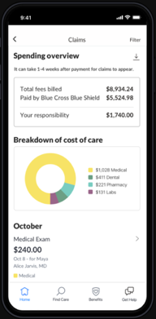
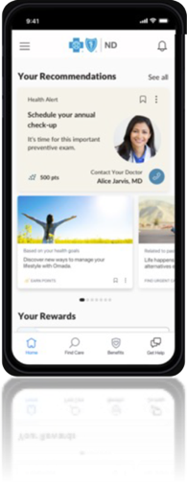
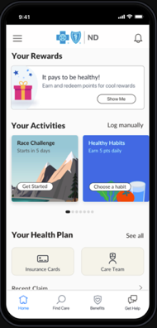
BCBSND.ME IMAGE LIBRARY

